# ****Historical Analysis for past two years, FY22 to 23**** **For historical data analysis, TouchNet (Sales data) and Blackbaud (Accounting data) are used. Since both systems are separate systems and there are differences in the data. So reliable data for the two years FY2022 and 2023 will be used. Please refer to the Appendix for graphs of each analysis and financial projection.**

# ****COGS Analysis****

# **To begin with the cost analysis, the results of COGS as a Percentage of Sales analysis shows that it has been approximately 50% to 70% for the past two years, but for the most recent two quarters, the values are as low as 50%.**

# ****SG&A Analysis****

# **The SG&A Breakdown highlights that “Personal Expenses”, which includes salaries, benefits, and insurance, account for the largest share throughout the past two years. This figure, with more than 90% is far ahead of other SG&A items such as Office Operation. However, there is a steady increase in the total SG&A expenses from FY2022 Q1 to FY2023 Q4 indicating that the trajectory can either be the upscaling with the operation or the inefficiencies with the cost management.**

# Gross Margin and Net Profit

# **Gross Margin is positive and on an increasing trend, while Net Profit, or profit before taxes, has been negative for two years in an increasing trend. This is clearly due in large part to SG&A's “Personal Expenses,” as discussed in the previous section.**

# Reconciliation Between TouchNet and Blackbaud

# **As mentioned at the beginning, there are differences in the data maintained by the two systems. This can be attributed to the following reasons, 1) The timing of entry into the accounting system (especially for September) is delayed, 2) monthly closing process has not been completed, and 3) transactions have not been finalized at the time of data extraction. It is essential that these differences be considered when conducting this type of financial analysis.**

**Financial Projection for next two years, FY24 to 25**

The current financial analysis indicates a concerning trend with a projected net profit of -$142.8K in the Q4 FY2025 if the current strategies are maintained this would to be the biggest challenge for CafeShop’s trajectory and marketability.

# ****Strategic recommendation****

To transform CafeShop into a saleable company, we aim to return it to profitability in a single quarter at least by 4Q FY2025. Two goals, Goal 1: Increase sales by 20% per year, Goal 2: Reduce labor costs (the main cause of losses) by 25% per year, will enable us to return to profitability. To achieve Goal 1, Four measures based on the analysis of each department will be proposal. Target figures will be set for each department responsible for selected products, and the measures will be implemented.

Two measures, 1) Improve operational efficiency (15% reduction),2) Business process improvement (10% reduction) will be implemented to achieve Goal 2. To promote these measures, our suggestion is the establishment of a cross-functional team. After approval, the concrete plan will be delivered within one month.

# ****Projections with strategies****

By implementing the above strategies, it is possible to return to profitability in a single Q by the end of FY2025. Continuous monitoring and prompt action in case of deviation from the plan are essential. The sale of CafeShop will become possible once we have achieved a transformation to sustainable management that will ensure a return to profitability in a single quarter in FY2026 and beyond and have appealed to investors and potential acquirers.

# Appendix:

*Figure 1: Historical COGS as Percentage of Sales*

*Figure 2: Breakdown of the SG&A Expenses by category*

*Figure 3: Gross Margin and Net Profit*



*Figure 4: Differences between TouchNet and Blackbaud sale data*

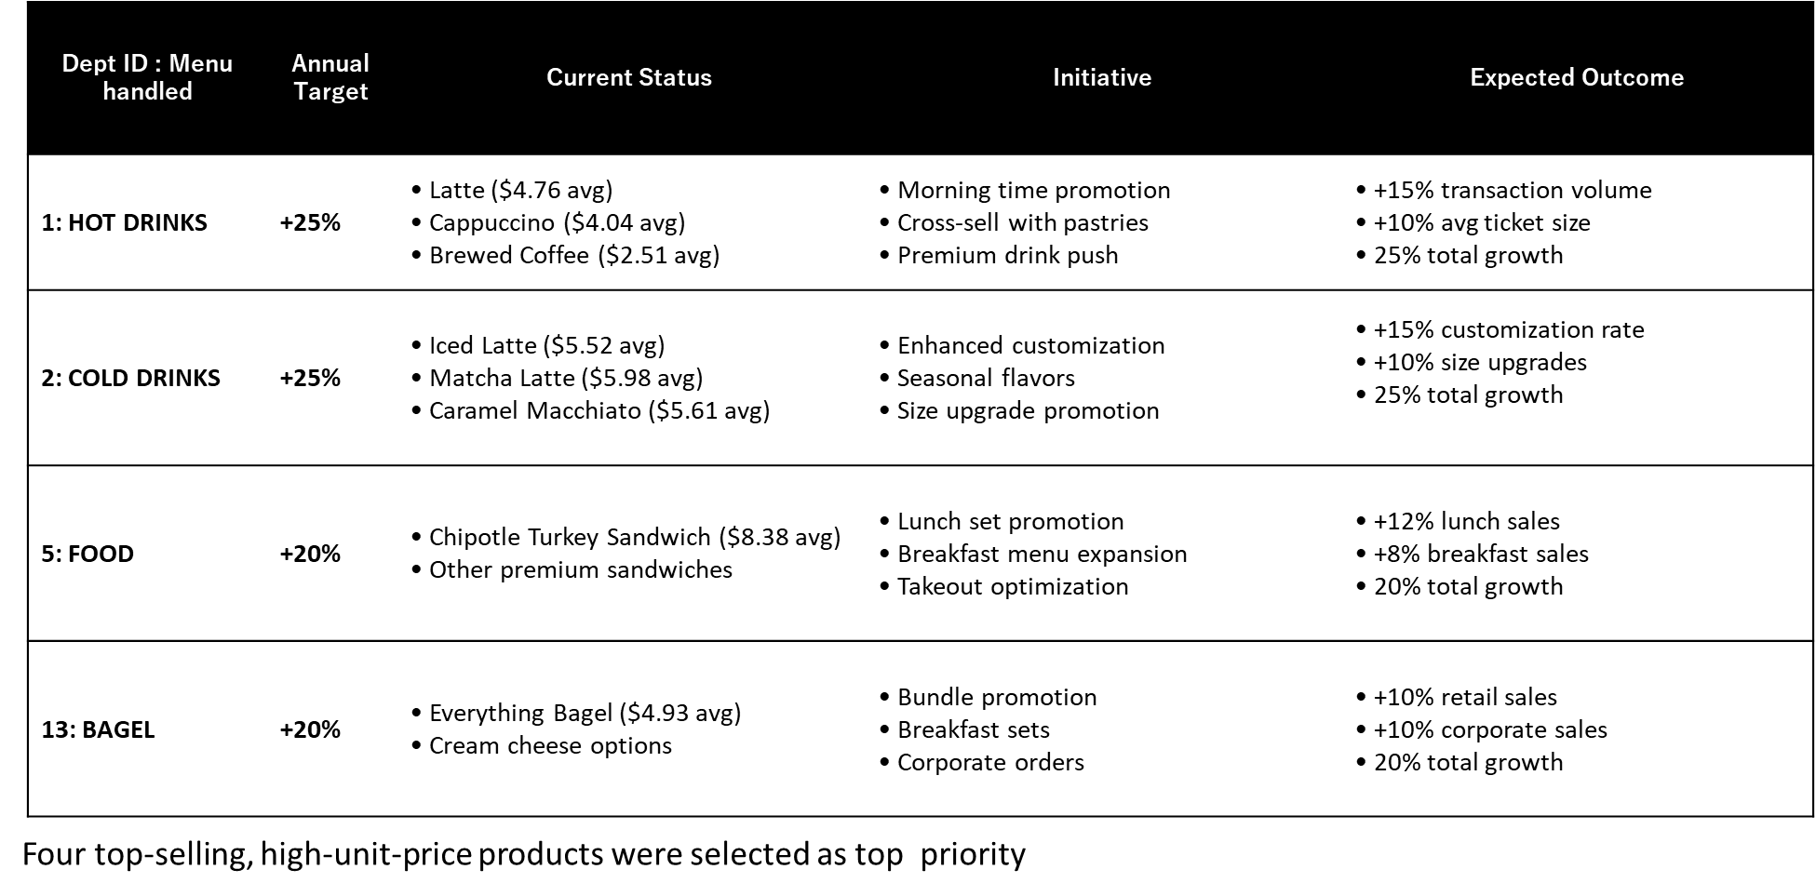

*Figure 5: Goal 1: Revenue Growth Strategy by Department (20% Total Growth Target)*

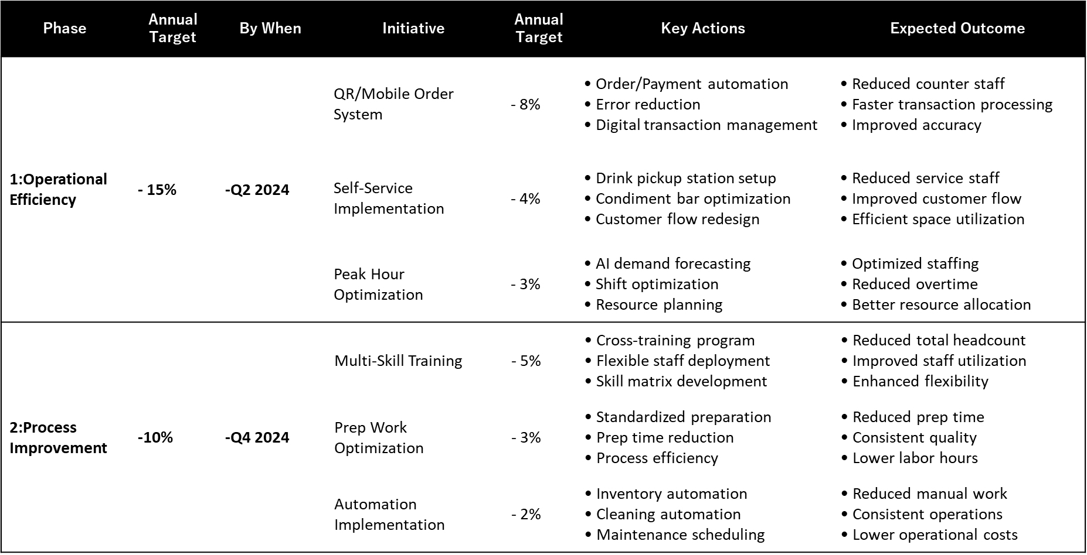

*Figure 6: Goal 2: Labor Cost Reduction Strategy (25% Total Reduction)*



*Figure 7: Future Projection for next two years without strategies*



*Figure 8: Future Projection for next two years with strategies*

# Information of connection of Azure Database:

Hostname : datamanagement.mysql.database.azure.com

Use name: prof_luis

Pass word: clever_password